Joshua Pollock

CS 200 Homework 6

March 22, 2017

1. Divide underflow is caused when a divisor is greatly smaller than the dividend (the number being divided from). A computer will see this as a zero-division error, as the smaller number exceeds the precision of the floating-point format. The divisor in this case would be represented by a 0.
2. A =1.0x2^10, B=-1.0x2^10, and c=1.0x2^0

C=1.0x2^0=0.00000000001x2^10

B+(A+C) :

=-1.0x2^10+(1.0x2^10+1.0x2^0)

=-1.0x2^10+(1.0x2^10+0.0000000001x2^10)

=-1.0x2^10+(1.0000000001x2^10)

=-1.0x2^10+1.00000000x2^10 because we can only have 8 bits in the mantissa

=-1.0x2^10+1.0x2^10

=0

(B+A)+C:

=(-1.0x2^10+1.0x2^10)+1.0x2^0

=0+1.0x2^0

=1.0x2^0

=1

Round off error will happen when one number is larger than others due to the limited number of bits given by the mantissa.

Multiplication does not run into this problem as it does not need the numbers to be expressed in the same powers of 2. The accuracy of the bits can still suffer with multiplication.

1. CRCs are commonly used in data transmission. If an error occurs during transmission of data, the sender can be asked to retransmit the data. You would want to use CRCs when you can ask the sender for retransmission.   
     
   Hamming Codes are particularly useful when correcting burst errors. This occurs when a series of bits that are adjacent to each other are damaged. An example of this would be a scratched CD. You would want to use Hamming codes when retransmission of data is not possible.

a.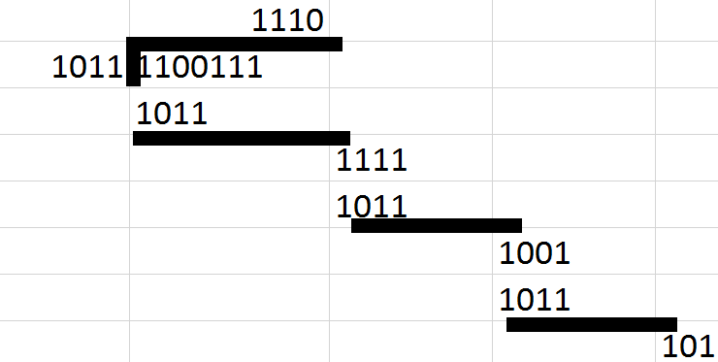

1110 with a remainder of 101

b. 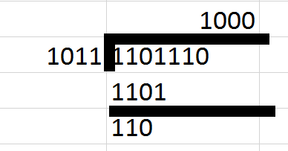

1000 with a remainder of 110

c. 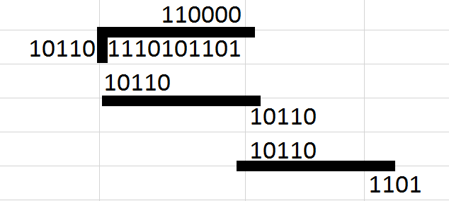

110000 with a remainder of 1101

d. 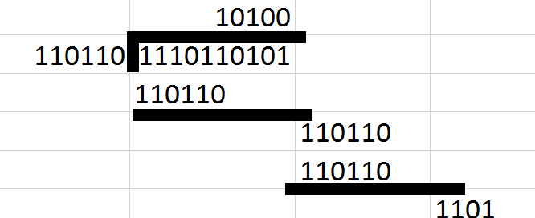

10100 with a remainder of 1101

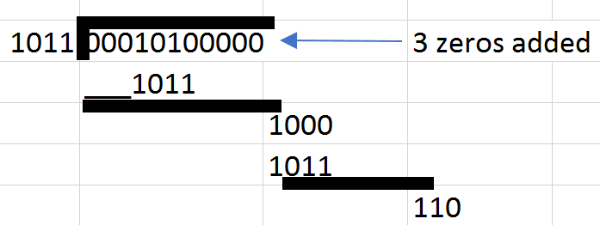

Codeword= 00010110000+101= 00010110101

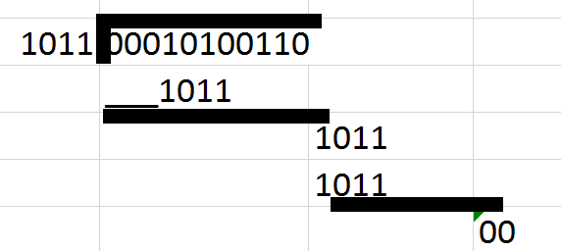

Remainder = 00